Abubakar Badamasi
FCP/CIT/18/1039
CIT 407 ASSIGNMENT
Chapter 3
Overview Of Mobile App Testing
Introduction to Mobile Application Testing
Mobile application testing is the process every application developed for handheld devices has to go through. This, obviously, is to assure a certain level of quality before an application is released into the market place (app store/ play store). Mobile application development life cycle generally tends to be much shorter than others, hence, heavily depend on mobile application testing for their success. Applications get tested on the basis of security, their functionality, usability etc. This increases the general efficiency of the application on all fronts while also increasing the reliability factor amongst users.

What is Mobile App Testing?
Mobile app testing is the process by which softwares are tested for it's functionality, usability and consistency.

Why mobile app testing is important?
The main goals of mobile application testing are to ensure that the finished product is stable and free of bugs, that it is easy and intuitive to use, and that it performs consistently across all devices and platforms.

Key Factors in Mobile Testing
1) Define your own scope of Testing.
2) Do Not Limit Your Testing.
3) Cross-Platform Testing.
4) Testing App Upgrade Scenarios.
5) App Permission Testing.

Types of Mobile App Testing:
To address all the above technical aspects, the following types of testing are performed on Mobile applications.
1) Usability testing : To make sure that the mobile app is easy to use and provides a satisfactory user experience to the customers
2) Compatibility testing: Testing of the application
on different mobile devices, browsers, screen
sizes, and OS versions according to the
requirements.
3) Interface testing: Testing of menu options, buttons, bookmarks, history, settings, and navigation flow of the application.
4) Services testing: Testing the services of the
application online and offline.
5) Low-level resource testing: Testing of memory
database growing issues known as low-level
resource testing.
6) Performance testing : Testing the performance of
the application by changing the connection from
2G, 3G to WIFI, sharing the documents, battery
consumption, etc.

Tools used in mobile app testing
There are several tools available for mobile app testing that can help ensure the quality and functionality of your mobile applications. Here are some commonly used tools:
1) Appium: Appium is an open-source automation tool for mobile app testing. It supports both Android and iOS platforms and allows you to write tests using popular programming languages such as Java, C#, and Python.
2) Selenium: Selenium is a widely used automation framework for web testing, but it also has support for mobile app testing through the use of additional tools and libraries.
3) Android Studio: Android Studio is the official integrated development environment (IDE) for Android app development.
4) TestFlight: TestFlight is a tool provided by Apple that allows you to distribute beta versions of your iOS apps to testers for testing and feedback.
5) AWS Device Farm: AWS Device Farm is a cloud-based testing service provided by Amazon Web Services. It allows you to test your Android and iOS apps on real devices hosted in the AWS cloud

Chapter 4
Introduction to deploying mobile apps to app stores (Google Play Store, Apple App Store)
Deploying a mobile app to app stores like the Google Play Store and the Apple App Store is an essential step in making your app available to a wider audience. Both platforms have specific guidelines and requirements that you need to follow in order to publish your app successfully. Here's an introduction to the process of deploying mobile apps to these app stores:
Google Play Store:
The Google Play Store is the primary app distribution platform for Android devices. To deploy your app on the Play Store, follow these steps:
a. Prepare your app: Make sure your app is fully developed, thoroughly tested, and meets the Google Play Store's policies and guidelines.
b. Create a developer account: Sign up for a Google Play Console account as a developer. This requires a one-time registration fee.
c. Provide app details: Fill in the necessary information about your app, such as title, description, screenshots, and promotional materials.
d. Upload the app: Create an APK (Android Package) file, which contains your app's code and resources, and upload it to the Google Play Console.
e. Set pricing and distribution: Decide whether your app will be free or paid, and select the countries or regions where it will be available.
f. Test and release: Google Play Console allows you to test your app internally or with selected beta testers before releasing it to the general public. Once you're satisfied, you can roll out the app to production.
Apple App Store:
The Apple App Store is the primary app distribution platform for iOS and macOS devices. To deploy your app on the App Store, follow these steps:
a. Join the Apple Developer Program: Enroll in the Apple Developer Program, which requires an annual fee.
b. Prepare your app: Develop your app using Xcode, Apple's integrated development environment (IDE). Ensure your app complies with Apple's App Store Review Guidelines, covering design, functionality, and content.
c. Create an App Store record: Use App Store Connect, Apple's platform for managing app submissions, to create an App Store record for your app.
d. Configure app pricing and availability: Choose whether your app will be free or paid, and set the price tiers for different regions.
e. Generate an app archive: Archive your app using Xcode, which creates an IPA (iOS App Store Package) file containing your app and its resources.
f. Submit for review: Upload the app archive to App Store Connect and submit it for review.
g. Release your app: Once your app is approved, you can schedule a release date or manually release it to the App Store.

Understanding app store guidelines and requirements
App store guidelines and requirements are sets of rules and criteria that developers must adhere to when submitting their apps to app stores like the Google Play Store and the Apple App Store. These guidelines ensure that the apps meet certain standards in terms of quality, security, content, and user experience.

Google Play Store Guidelines:
a. Content Policies: Apps must not contain prohibited content.
b. User Data and Privacy: Apps should handle user data responsibly and follow Google's policies on data collection, storage, and usage.
c. App Quality and Performance: Apps must be stable, perform well, and provide a good user experience.
d. Security and Malware: Apps must not contain or promote malicious software, malware, or engage in any harmful activities.
Apple App Store Guidelines:
a. App Functionality: Apps should function as described, and any advertised features should work properly.
b. User Interface and Design: Apple emphasizes the importance of clean, intuitive, and visually appealing user interfaces.
c. Content Policies: Apps must not include offensive, violent, or illegal content.
d. App Review Process: Apple has a stringent app review process to ensure compliance with their guidelines

Chapter 5
Overview of Mobile App Analytic?
Mobile app analytics is an important viral marketing tool and is essential for software developers, product managers, and app marketing teams. They give you real insights into how users are behaving: what’s working for them and what isn’t. These enable you to make data-driven decisions about how to improve the product rather than operating on potentially-faulty assumptions.

What is Mobile App Analytic?
Mobile app analytics is the practice of collecting, measuring, analyzing, and interpreting data related to mobile applications. It provides valuable insights into user behavior, engagement, and overall app performance, enabling app developers and marketers to make data-driven decisions and optimize their mobile apps for better user experiences.

How to track and analyze app usage data to improve app performance and user experience.
1) Define goals and metrics.
2) Implement analytics tools.
3) Track relevant events.
4) Set up user segmentation.
5) Monitor performance and crashes.
6) Collect user feedback.
Chapter 6
Introduction to Mobile App Security?
Mobile application security focuses on the software security posture of mobile apps on various platforms like Android, iOS, and Windows Phone. This covers applications that run both on mobile phones as well as tablets. It involves assessing applications for security issues in the contexts of the platforms that they are designed to run on, the frameworks that they are developed with, and the anticipated set of users (e.g., employees vs. end users). Mobile applications are a critical part of a business’s online presence and many businesses rely entirely on mobile apps to connect with users from around the world.

What is Mobile App Security?
Mobile app security refers to the measures and practices employed to protect mobile applications from potential threats, vulnerabilities, and unauthorized access.

Best practices for securing user data and protecting against malicious attacks
1) Use encryption.
2) Employ Access Control.
3) Implement strong authentication.
4) Input validation and sanitization.
5) Implement secure password practices.

INTRODUCTION TO REACT
React library is built on a solid foundation. It is simple, flexible and extensible. As we learned earlier, React is a library to create user interface in a web application. React’s primary purpose is to enable the developer to create user interface using pure JavaScript. Normally, every user interface library introduces a new template language (which we need to learn) to design the user interface and provides an option to write logic, either inside the template or separately. Instead of introducing new template language, React introduces three simple concepts as given below:
React elements
JavaScript representation of HTML DOM. React provides an API, React.createElement to create React Element.
JSX
A JavaScript extension to design user interface. JSX is an XML based, extensible language supporting HTML syntax with little modification. JSX can be compiled to React Elements and used to create user interface.
React component
React component is the primary building block of the React application. It uses React elements and JSX to design its user interface. React component is basically a JavaScript class (extends the React.component class) or pure JavaScript function. React component has properties, state management, life cycle and event handler. React component can be able to do simple as well as advanced logic.
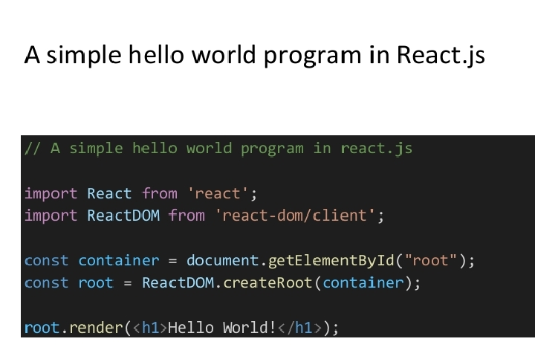
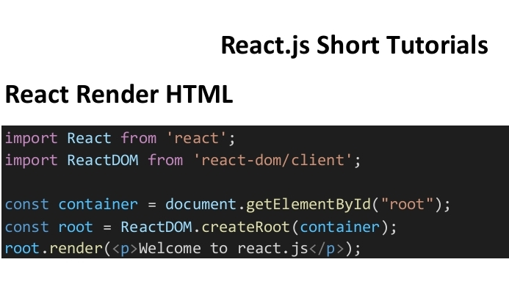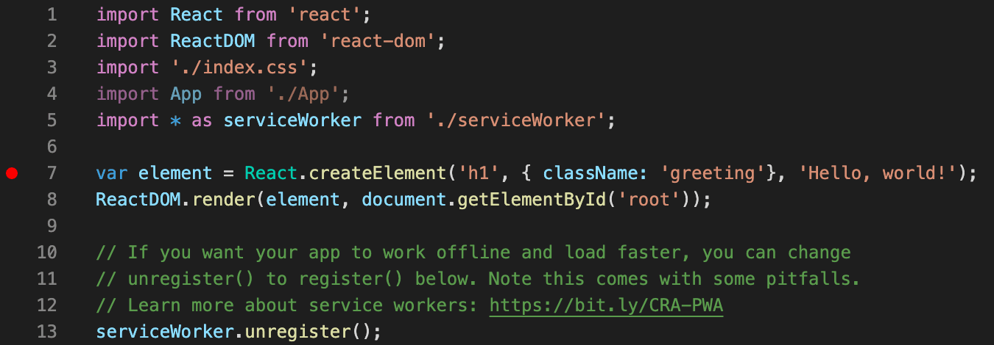

React Component 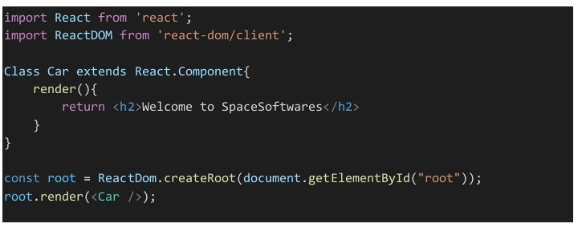

Function components are the same with class components but are written with less code and easier to understand.
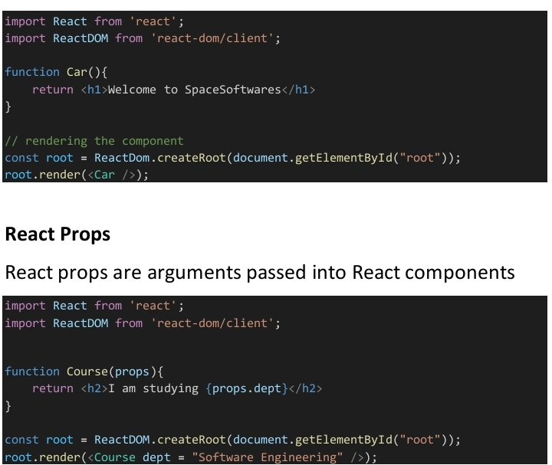
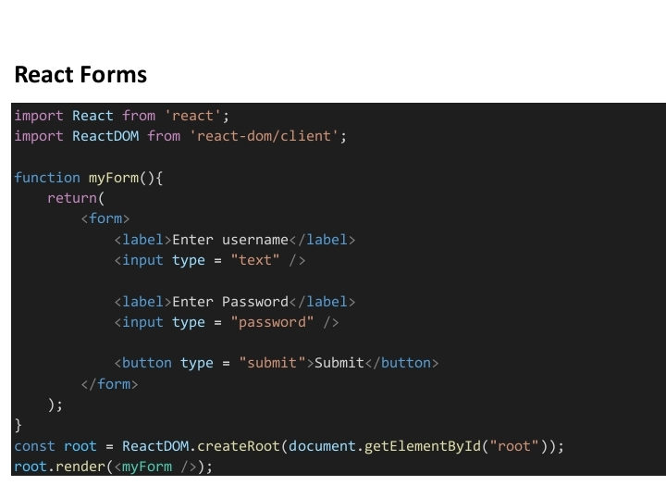

INTRODUCTION TO REACT NATIVE
React Native lets you build mobile apps using only JavaScript. It uses the same design as React, letting you compose a rich mobile UI from declarative components. With React Native, you don't build a mobile web app, an HTML5 app, or a hybrid app; you build a real mobile app that's indistinguishable from an app built using Objective-C or Java. React Native uses the same fundamental UI building blocks as regular iOS and Android apps. You just put those building blocks together using JavaScript and React.

React Native Features
Following are the features of React Native:
React – This is a Framework for building web and mobile apps using JavaScript.
Native − You can use native components controlled by JavaScript.
Platforms – React Native supports IOS and Android platform.

React Native Advantages
Follow are the advantages of React Native:
JavaScript − You can use the existing JavaScript knowledge to build native mobile apps.
Code sharing − You can share most of your code on different platforms.
Community – The community around React and React Native is large, and you will be able to find any answer you need.

React Native Limitations
Following are the limitations of React Native:
Native Components − If you want to create native functionality which is not created yet, you will need to write some platform specific code.

